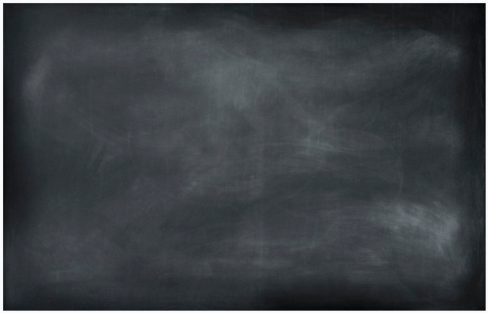
MAKE YOUR OWN CHALKBOARD !

You’ll need:

- A piece of MDF about A1 in size (59.4 x 84.1 cm/23.4 x 33.1 inch) or larger. For reference my chalkboard is 100 x 85 cm.

You can also paint directly on a wall surface or the back of a door in your living space.

- Chalkboard paint – in black, green or white as you prefer.

IMPORTANT: Don’t buy Chalk paint! Make sure it says chalkboard paint on the tin.

- A paint roller and paint tray.

- Fine sandpaper.

Make your chalkboard:

1) Take your piece of MDF and give it a light sand with your sand paper. This will help the chalkboard paint to adhere more easily to the wood.

2) Pour some chalkboard paint into your painting tray dip your paint roller in the paint and cover your sheet of wood.

Decide if you want a different colour on each side of your board. Mine has black chalkboard paint on one side and white on the other .

3) Give your board 2-3 coats of paint as needed to get a really good covering. Let the coats of paint dry completely in between.
Don’t forget to freshen up your chalkboard once or twice a year with a new coat of paint as you see fit.

To draw on my board I use the little round chalk sticks that is normally used in schools. But if you don’t want the mess with chalkdust in the air and on the floor, you can buy dust free chalks.

So what’s the best chalk to draw with? Here’s an article to make you a little wiser…

